InHARD Dataset- Data visualization

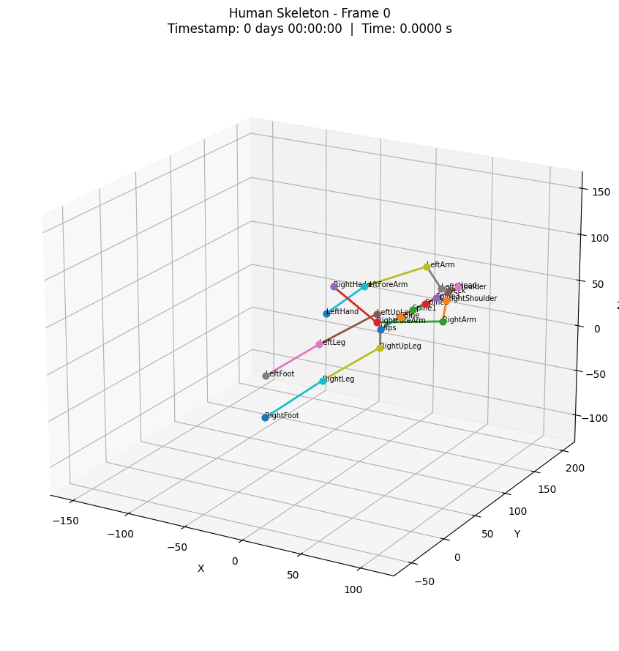
Saved in folder: skeleton_plots

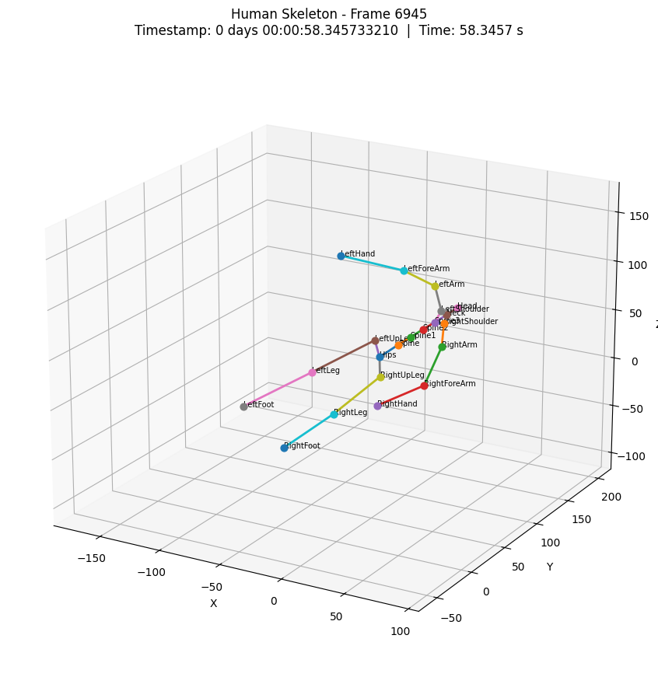
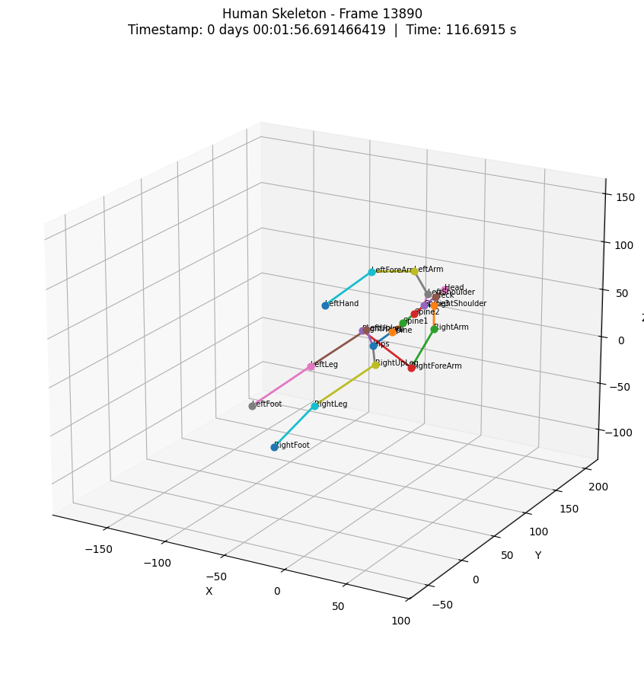

Skeleton graph using PyMO library
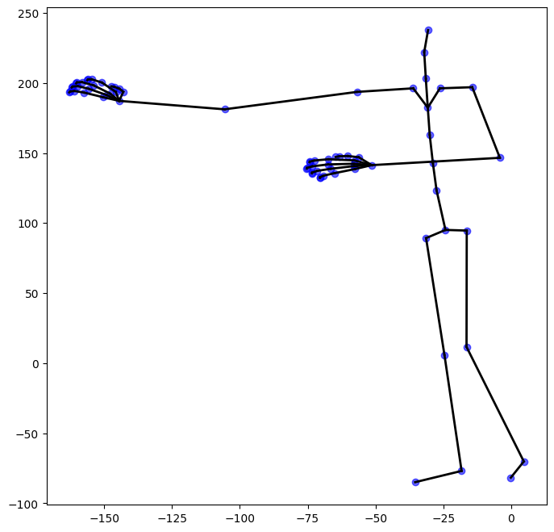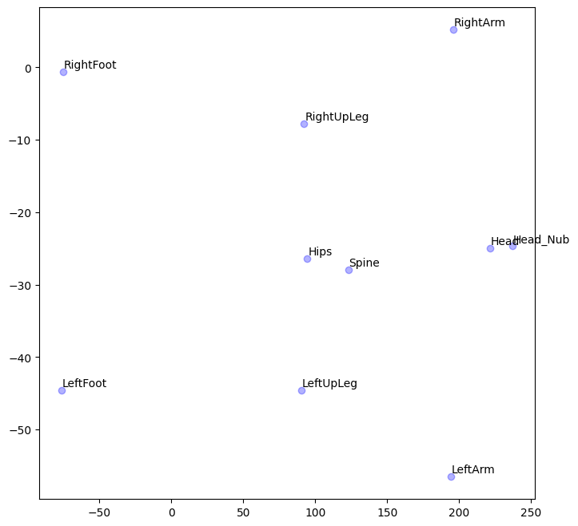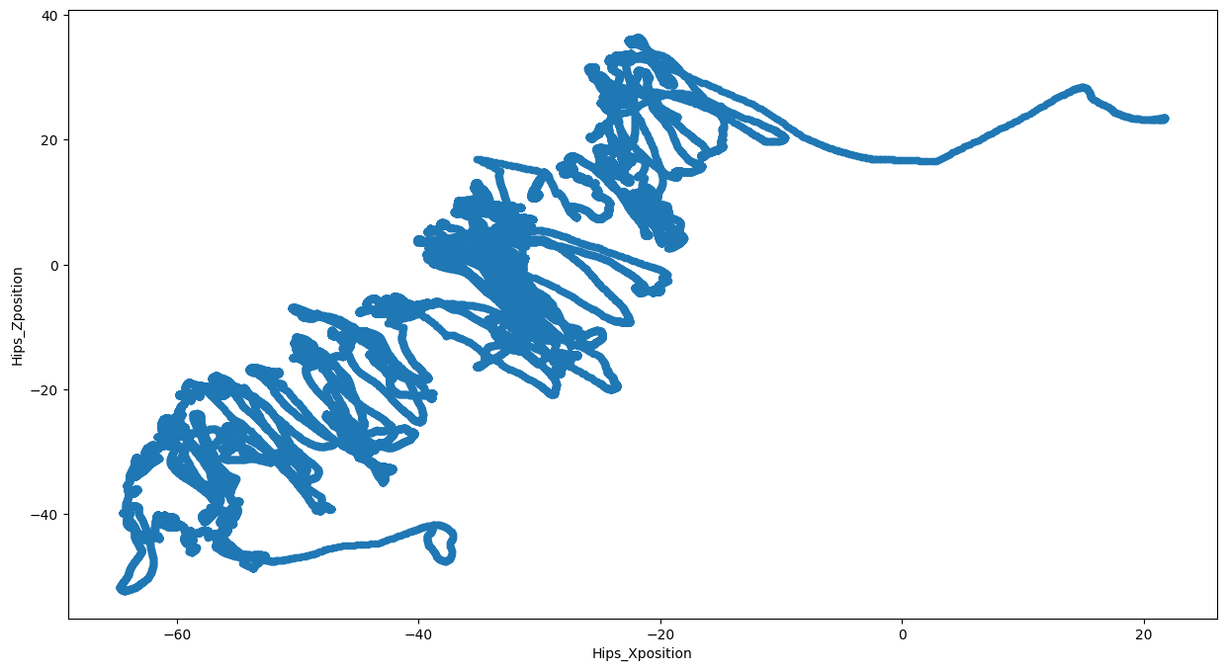

PIMNET model results metrics

===== PIMNet (physics-infused) | device=cpu =====
[physics] floor_height=None -> contact forces set to zero (free-space arm motion).
train windows: 49960 | val windows: 12458 | input dim: 33 | output dim: 21
epoch 1 | train 0.00134 | val 0.00115 | lr 1.0e-03
epoch 5 | train 0.00077 | val 0.00177 | lr 1.0e-03
epoch 10 | train 0.00057 | val 0.00159 | lr 5.0e-04
epoch 15 | train 0.00050 | val 0.00215 | lr 2.5e-04
early stopping at epoch 17 (best val 0.00113)

PIMNet (physics-infused)
TRAIN: R2=0.9901 MSE=0.000194 MAE=0.006264
VAL : R2=0.9854 MSE=0.000257 MAE=0.007151
VAL baseline (repeat last frame): R2=0.9878 MSE=0.000210 MAE=0.005297

===== ED ablation (no physics) | device=cpu =====
train windows: 49960 | val windows: 12458 | input dim: 21 | output dim: 21
epoch 1 | train 0.00130 | val 0.00126 | lr 1.0e-03
epoch 5 | train 0.00075 | val 0.00161 | lr 1.0e-03
epoch 10 | train 0.00057 | val 0.00174 | lr 5.0e-04
epoch 15 | train 0.00051 | val 0.00175 | lr 2.5e-04
early stopping at epoch 17 (best val 0.00118)

ED ablation (no physics)
TRAIN: R2=0.9900 MSE=0.000195 MAE=0.006344
VAL : R2=0.9845 MSE=0.000260 MAE=0.007235
VAL baseline (repeat last frame): R2=0.9878 MSE=0.000210 MAE=0.005297

R2_train R2_val MSE_train MSE_val MAE_train MAE_val
PIMNet 0.99015 0.98537 0.00019 0.00026 0.00626 0.00715
ED (no physics) 0.99003 0.98455 0.00020 0.00026 0.00634 0.00723

